Commands Utilities
This assignment expects the participant to identify specific command(s) OR perform the given action using one or commands as per the given question. You are requested to maintain the answers (i.e command(s) as per given question) for all questions below.
Mandatory Questions
- Which command is used to know the current working directory?
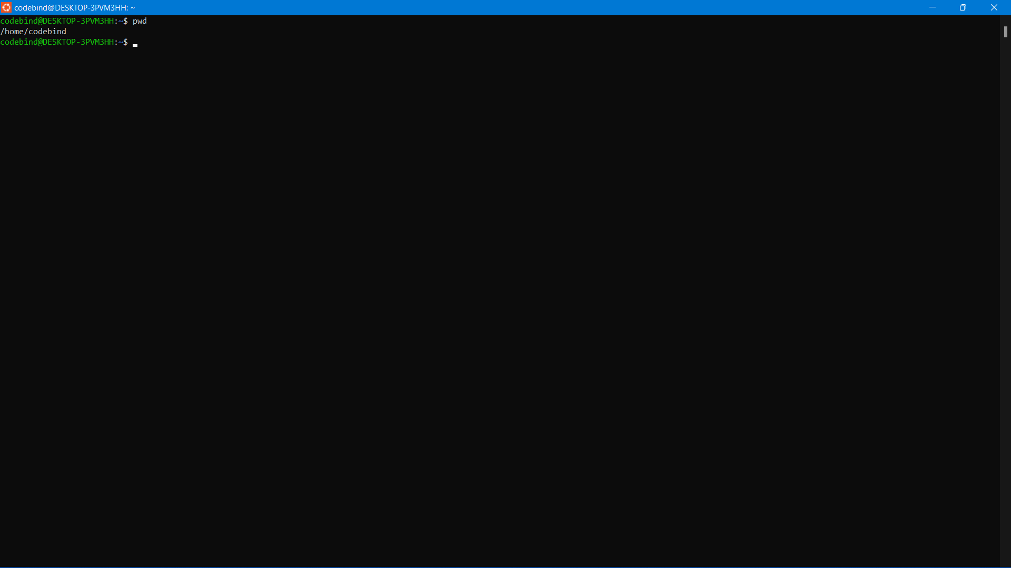
- How would you find out its contents?
ANS:- cat >file.txt
Hello linux

- Identify the commands with inputs to do the following
  - create a directory d1
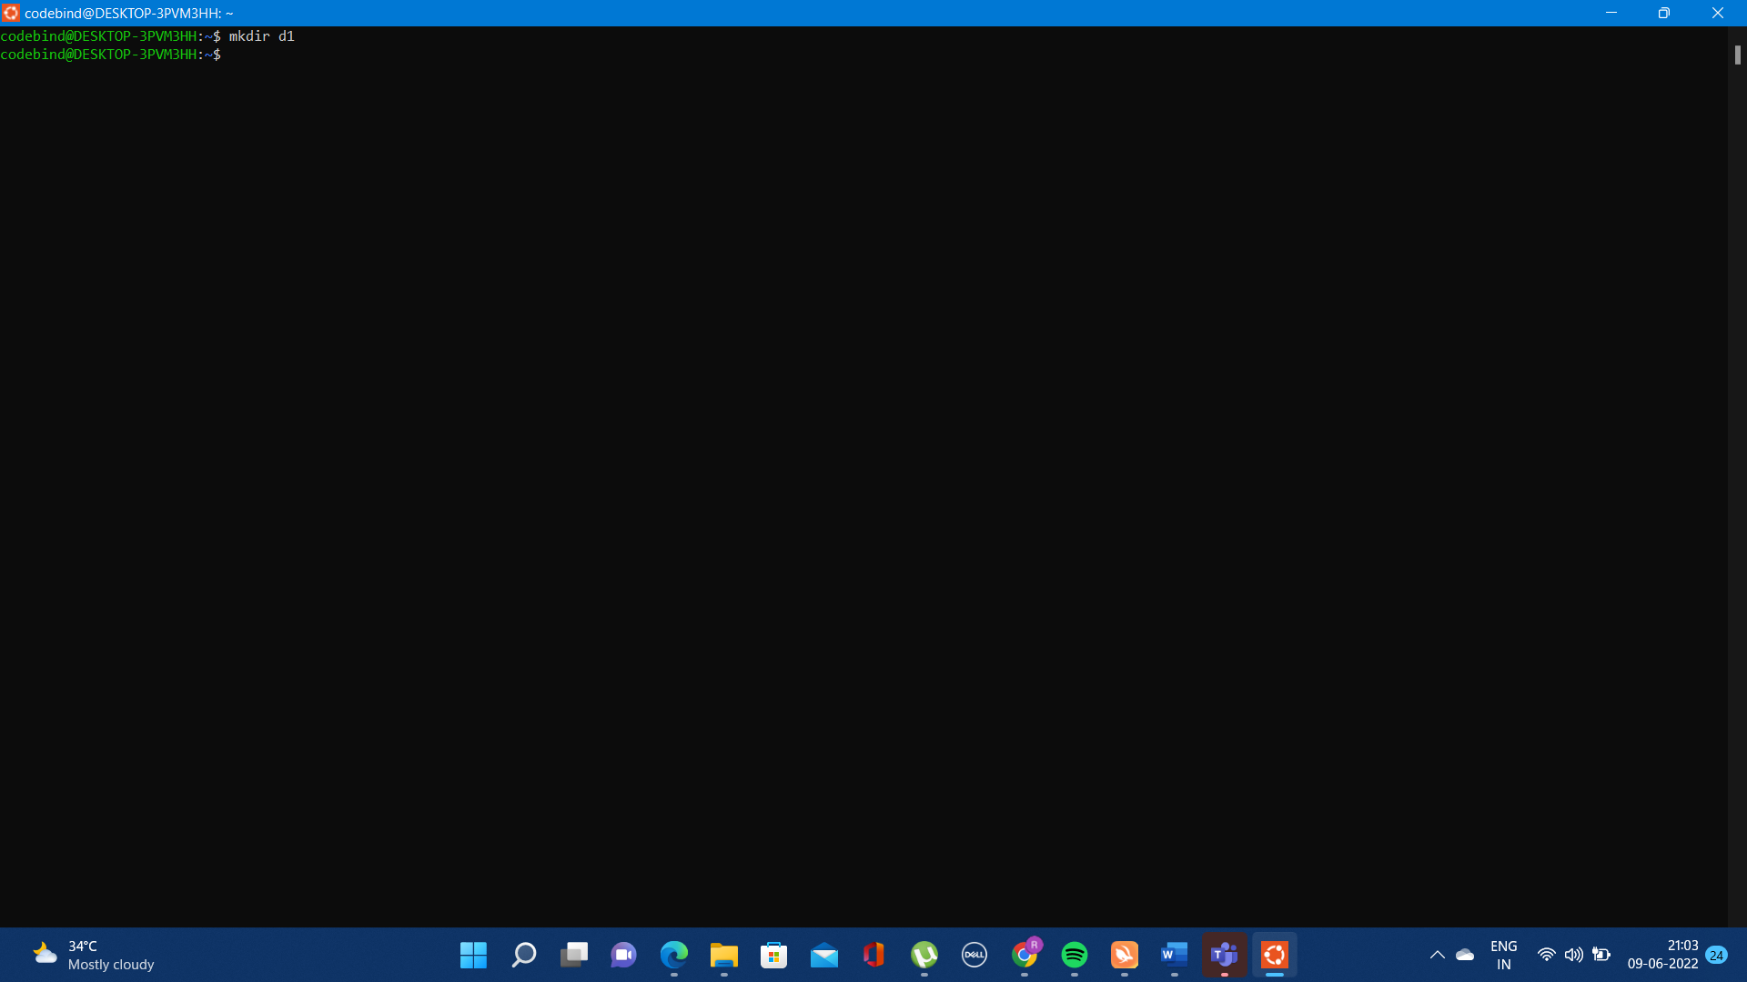
  - create a subdirectory d2 in d1
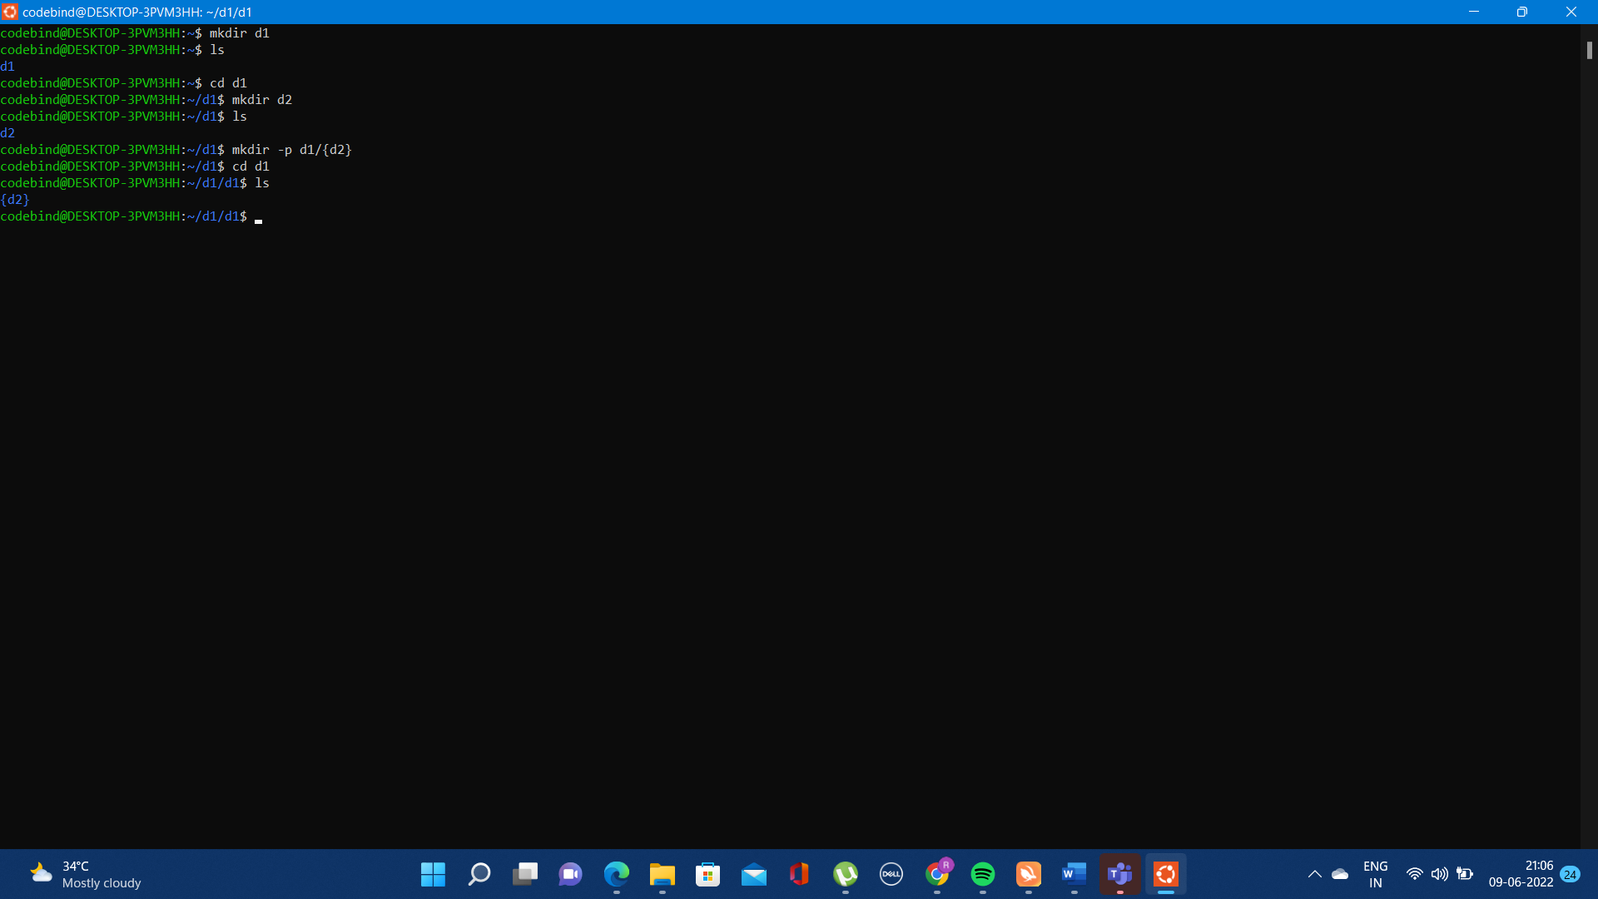
  - change to directory d2
  - create an empty file “f1.txt”
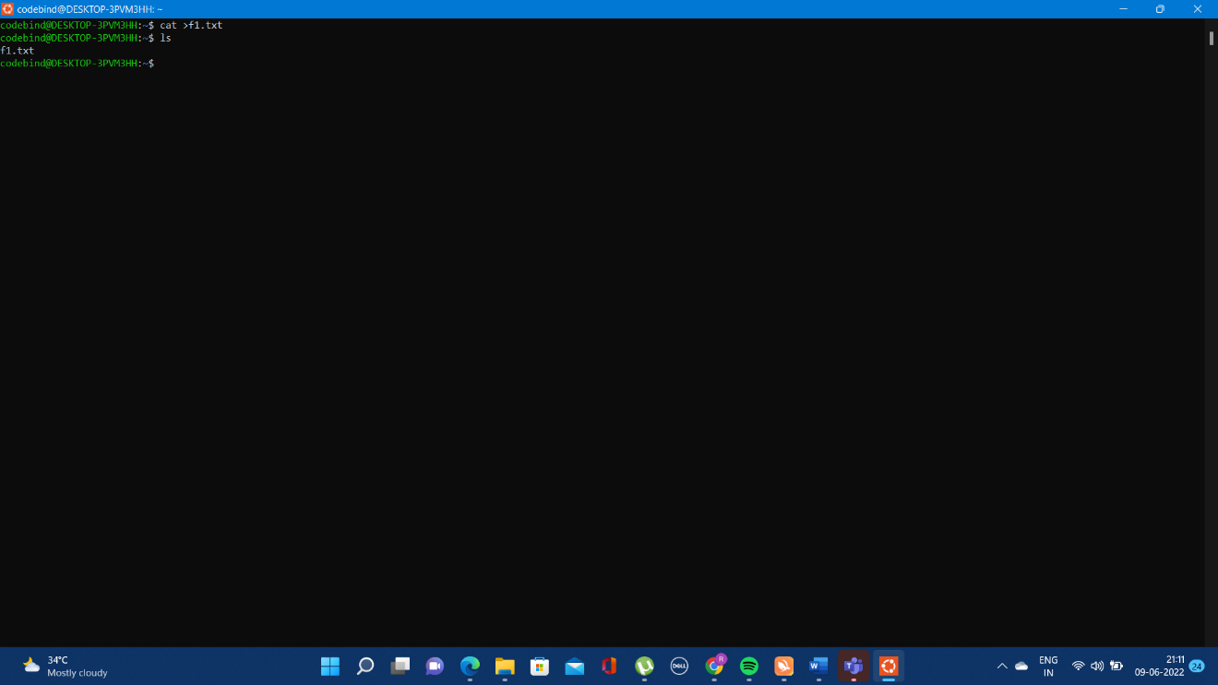

  - display the contents of “f1.txt”
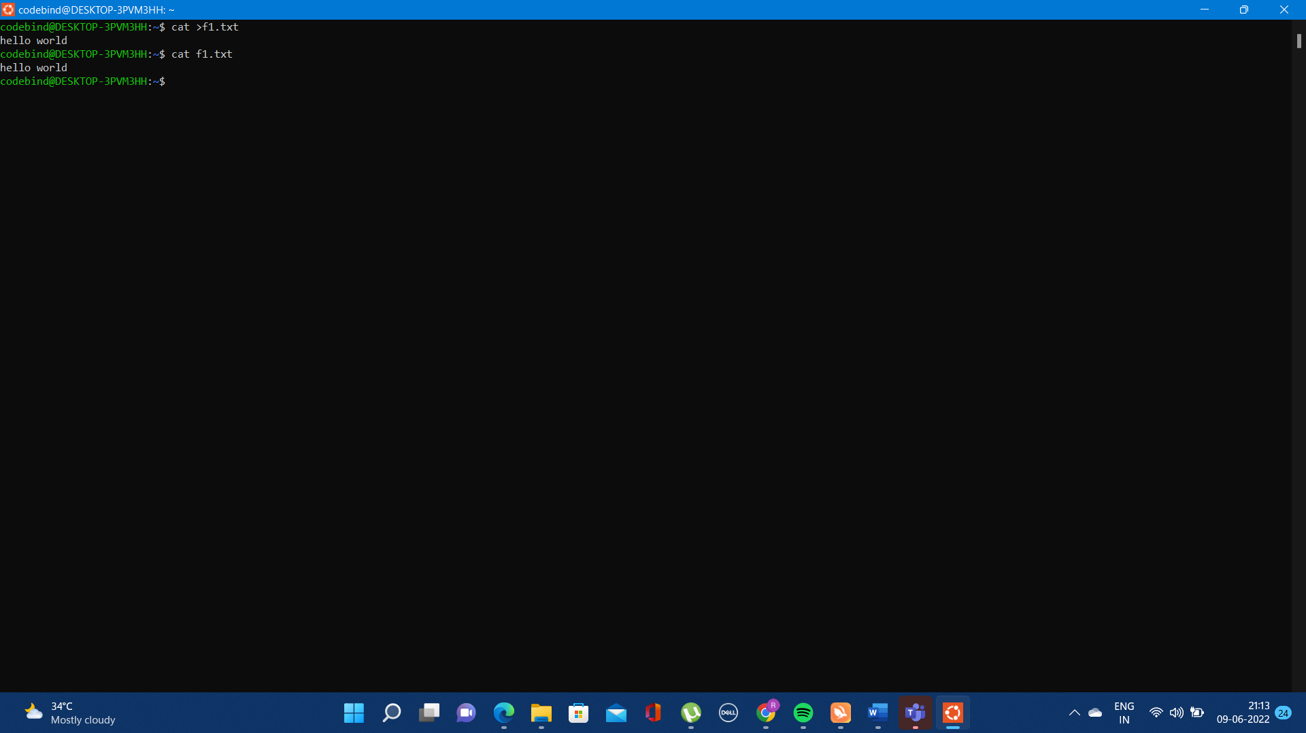

  - view the contents of d1 from current directory d2
ANS:- ls
- Use the ls command with its options. How will you identify directories from the listing?
ANS:- ls
- Use ls to do the following
  - List files with single character names.

  - List hidden files also. [ Note : Hidden files are files having name started with a “.” ]

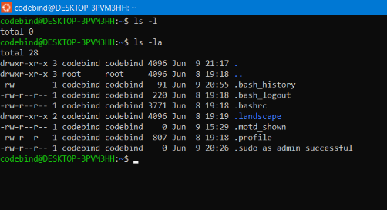
  - Suppose there are files tb1.1, tb2.1, tb3.1, ….tb10.1. Write command to list all the files [Hint: use wild card characters]
ANS:- touch tb1.2 tb2.1 tb3.1 tb4.1 tb5.1 tb6.1 tb7.1 tb8.1 tb9.1 tb10.1
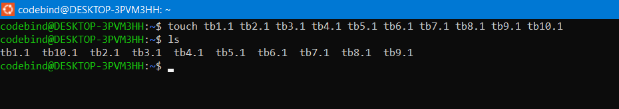
- Write the command to list all files in descending order of their size.
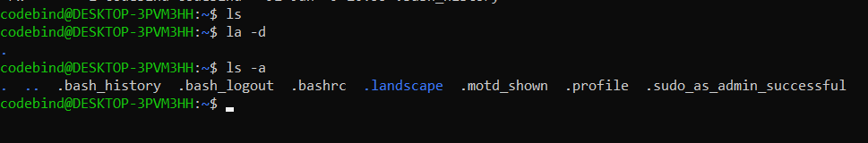
- Suppose there are files temp1, temp2, temp3. Write command to remove the files without listing them explicitly
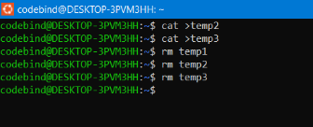

- Which command is used to list top few lines in the file?
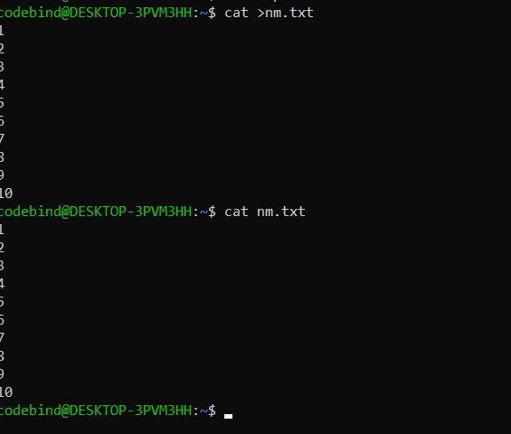
- Create a directory “testdir”
Ans:- mkdir testdir
cd testdir
- Use cp command to do the following
  - Copy the file tb1.1 (created above) in the same directory.
Ans:- cp tb1.1
  - Write a command to copy all the files i.e tb1.1,tb2.1,tb3.1,…..tb10.1 in a new directory –“new”

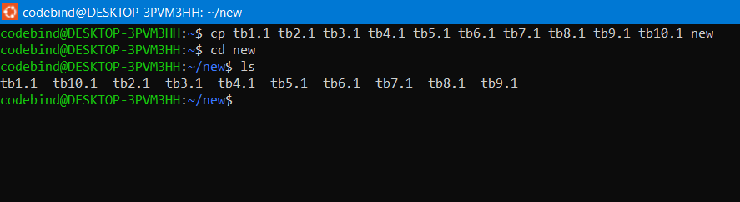
  - Create a subdirectory in new in named“new1”.
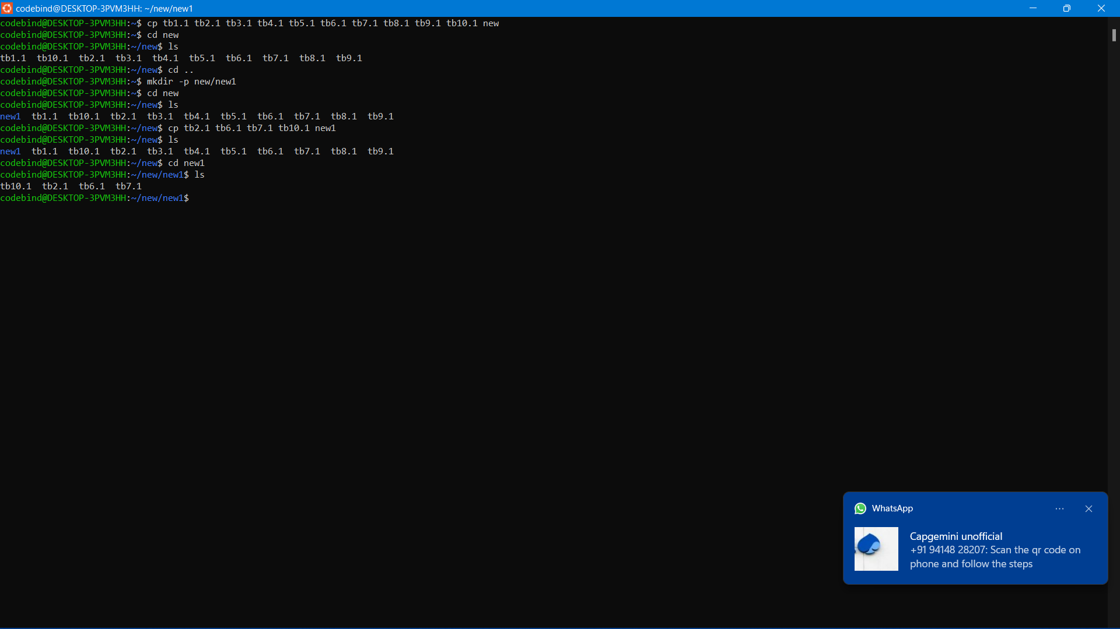
  - Write a command to copy selectively only tb2.1, tb6.1, tb7.1 and tb10.1 in the directory new1.
  - Write a command to copy the entire directory “new” to a directory “newprogs”. [Note : use the –R option of “cp” command ]
Ans:- cp -R
- Find out the difference between
  - “mv” & “cp”
Ans: mv: To move files and directories from one directory to another or to rename a file or directory.
cp: Copies the file.
  - “rm”, “rmdir”
Ans: rm: To remove the files
rmdir: To remove directory
  - “mkdir” and “mkdir -p”
Ans: mkdir: To create a new directory
mkdir -p: To create multiple directories within the directory
- Use a single command rmdir once to remove “testdir” and all its sub directories and files created above.
Ans:- rmdir testdir
- Which command is used to get the manual information of a command?
Ans:- man touch
- If you are not able to change to a directory what could be the likely cause?
Ans: It may happen that you are trying to cd into a file. The same message is thrown then. This may happen when something that you think should be a directory, is a file in reality. Well, Permission denied and Not a directory are different errors, and both describes what's wrong pretty clearly.
If you receive an error telling you that you do not have permissions to create a directory or to write a file to a directory then this is likely an indication that your script is attempting to write to a directory that the user running the build does not own.
- Explain the differences among the following commands:
a. cd / : This command is used to change directory to the root directory, The root directory is the first directory in your filesystem hierarchy.
b. cd .. : This command is used to move to the parent directory of current directory, or the directory one level up from the current directory. “..” represents parent directory.
c. cd : Change directory
\d. cd ../.. : To go to two times of parent folder

Advanced Optional Questions
2. What is the pipe symbol? What effect does it have?
Ans: A Pipe is a form of redirection (transfer of standard output to some other destination) that is used in Linux and other Unix-like operating systems to send the output of one command/program/process to another command/program/process for further processing. The Unix/Linux systems allow stdout of a command to be connected to stdin of another command. You can make it do so by using the pipe character ‘|’.
Syntax: command_1| command_2

3. 3. Find out the details of “ps” command ?
Ans: ps command is used to list the currently running processes and their PIDs along with some other information depends on different options. It reads the process information from the virtual files in /proc file-system. /proc contains virtual files, this is the reason it's referred as a virtual file system

